 VINOD SIR’S GROUP TUTION

MARKS: 22 SCIENCE-VIII TIME: 1 Hr. 30 Mins.

Q. 1: Draw the diagram of Fungi [3]

Q. 2: Complete the following chart: [3]
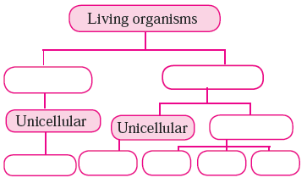

Q. 3: Find out my partner: [2]
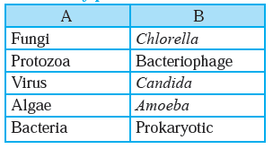

Q. 4: State whether the following statements are true or false. Explain your statement. (Any 3) [3]
a. Lactobacilli are harmful bacteria.
b. Cell wall of fungi is made up of chitin.
c. Organ of locomotion in amoeba is pseudopodia.
e. Tomato wilt is a viral disease.

Q. 5: Answer the following questions: (Any 3) [6]
a. State the merits of Whittaker’s method of classification.
b. Write the characteristics of viruses.
c. Explain the nutrition in fungi.
d. Which living organisms are included in the kingdom monera ?

Q. 6: Who am I ? (Any 5) [5]
a. I don’t have true nucleus, cell organelles or plasma membrane.
b. I have nucleus and membrane bound cell orgenelles.
c. I live on decaying organic matter.
d. I reproduce mainly by cell division.
e. I can produce my replica.
f. I am green, but don’t have organs.

